**GROCERY WEB APP USING MERN STACK**

**1. Introduction**

The Online Grocery Shopping Web App is a comprehensive platform designed to streamline the grocery shopping experience by providing a user-friendly and responsive interface where customers can browse, select, and purchase a range of grocery items. This project was built by a team of dedicated professionals, each specializing in different areas.

The Full Stack Developer, [Satheesh M], leads the project with a focus on end-to-end development and integration.

The Backend Developer, [Shakthi S], focuses on server-side operations, ensuring smooth data management and security.

The Frontend Developer, [Sudhan Santhosraj J], implements and refines the user interface, while the UI/UX Designer,

[Srinath M], works to create an intuitive and aesthetically pleasing shopping experience.

**2. Project Overview**

This project was conceived with the purpose of providing customers with a secure, convenient, and efficient way to shop for groceries online. By eliminating the need for physical shopping trips, the app enables users to browse through a curated catalog, read detailed product descriptions, and add desired items to their carts with ease. Core features include responsive navigation across devices, personalized product recommendations, and a secure checkout process that offers multiple payment options. The platform also includes a robust backend that allows sellers to manage product listings, update inventory, and monitor orders efficiently. For administrators, the app offers an interface to track app performance, address customer inquiries, and ensure data security, making it an ideal choice for both customer and business needs.

**3. Architecture**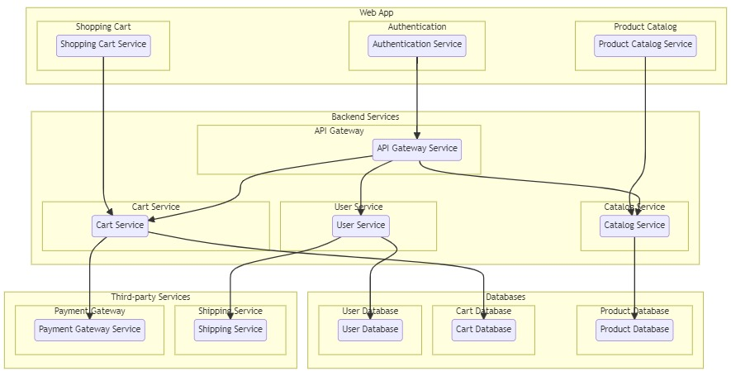

The frontend is developed using “React”, allowing for a highly interactive and adaptable user experience. React components power every part of the interface, from product displays and search filters to the shopping cart and checkout flow. This modular architecture not only makes the interface responsive and fast but also streamlines the development and maintenance process.

The backend is constructed with “Node.js” and “Express.js”, which handle the server-side operations, including API routing, data processing, and security protocols. This setup provides a strong backbone for data requests, making the interactions between the frontend and database seamless and secure.

“MongoDB” serves as the project’s database, storing and managing the information necessary for the app to function smoothly. The schema is structured with collections dedicated to users, products, orders, and categories, allowing for efficient retrieval and updates of product listings, user profiles, and order histories. This database setup ensures that large volumes of data can be handled quickly, without compromising performance.

**4. Setup Instructions**

To set up this project, certain prerequisites are required:

- Node.js (v14 or higher) for handling server-side scripts.

- MongoDB (either locally hosted or on MongoDB Atlas) for data management.

- Git to manage version control and codebase changes.

To install the project, first clone the repository using git clone [repository link]. Once cloned, navigate to the project directory and install dependencies for both the backend and frontend:

- In the server directory, run npm install to set up backend dependencies.

- In the client directory, run npm install to install frontend dependencies.

It’s essential to set up .env files containing environment variables like database URIs and API keys to configure the project’s secure connection to the database and external APIs.

**5. Folder Structure**

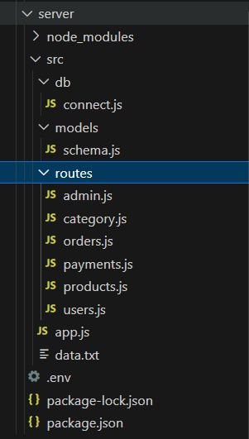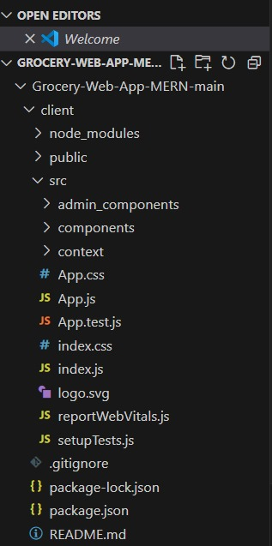**Client: Server:**

The folder structure is organized to maintain a clean and modular architecture.

**- Client:** This folder contains subfolders for components (for UI elements), pages (for different views like Home, Product, and Cart), assets (for images and styling), and services (for handling API requests). This organization keeps the React components modular and easier to update.

- **Server**: This folder includes the routes (API endpoints), controllers (business logic), models (MongoDB schemas), middleware (for security functions like authentication), and configuration files. This modular design allows each part of the backend to handle specific functions, simplifying the development process.

**6. Running the Application**

To run the application locally:

- Start the frontend server by navigating to the client directory and executing npm start.

- Start the backend server by navigating to the server directory and executing npm start.

**7. API Documentation**

The backend provides several endpoints that facilitate communication between the client and server:

- GET /products: Returns a list of available products.

- POST /users/register: Registers a new user, saving their information to the database.

- POST /users/login: Authenticates a user and generates an authentication token for secure access.

- GET /orders: Retrieves a user’s order history.

- POST /orders*: Allows users to place a new order.

Each endpoint has associated request methods, parameters, and structured responses to ensure consistent and reliable data handling.

**8. Authentication**

This project uses JWT (JSON Web Tokens) to manage authentication and authorization. Upon login, the backend generates a token that is stored on the client-side and used in subsequent requests to verify the user’s identity. Role-based access is implemented, granting or restricting permissions based on the user’s role (e.g., admin, seller), thereby enhancing data security.

**9. User Interface**

The user interface is built with a focus on accessibility and ease of navigation. Screenshots or GIFs of the homepage, product listing page, product details page, cart, and checkout pages provide a clear representation of the user journey from browsing to purchasing, showcasing a consistent and streamlined experience.

**10. Testing**

The app follows a well-defined testing strategy:

- Unit Testing is performed with Jest to validate individual components and functions, ensuring each element works as expected.

- Integration Testing leverages Supertest to verify that API endpoints interact correctly with the database and business logic.

- End-to-End Testing uses Cypress to simulate real user interactions and verify the overall functionality of the application.

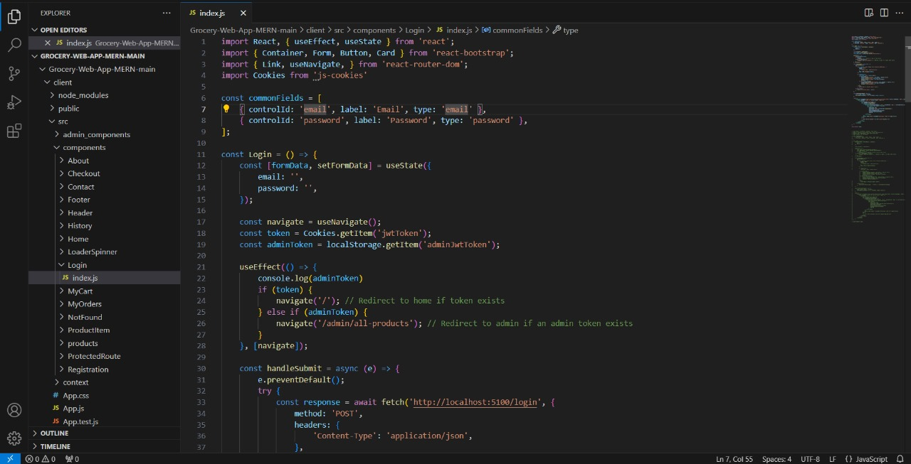**11. Screenshots**

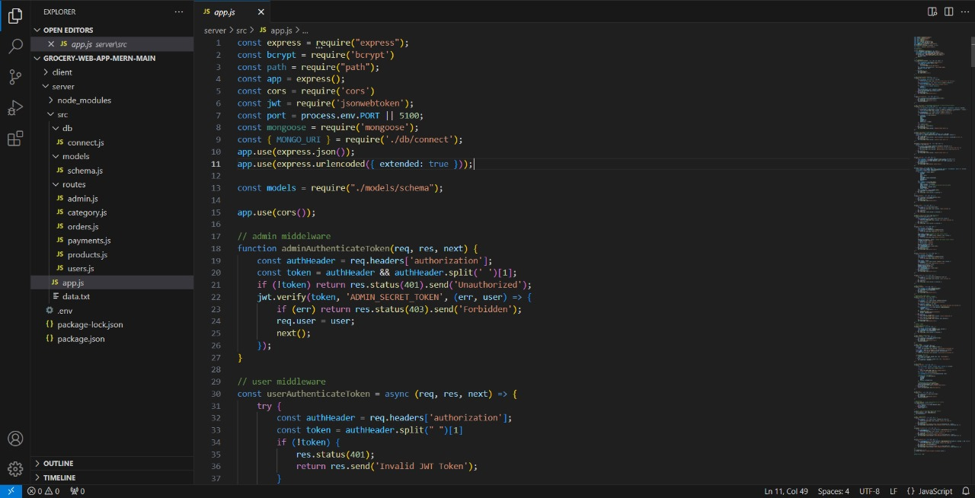

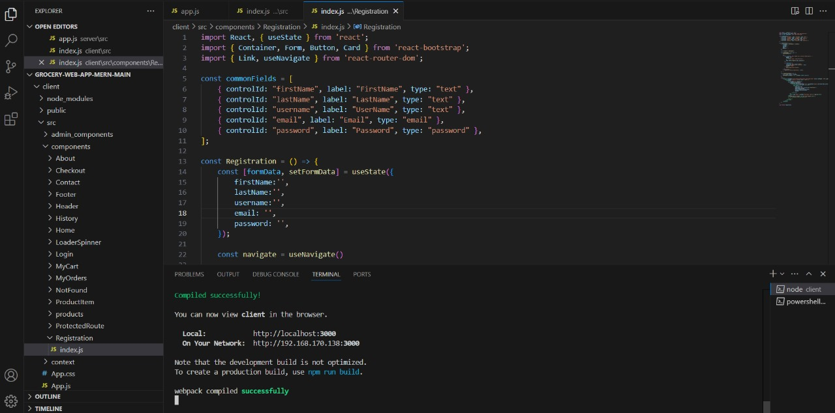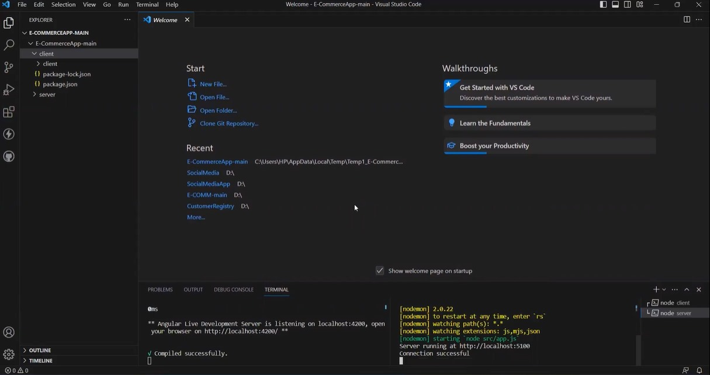

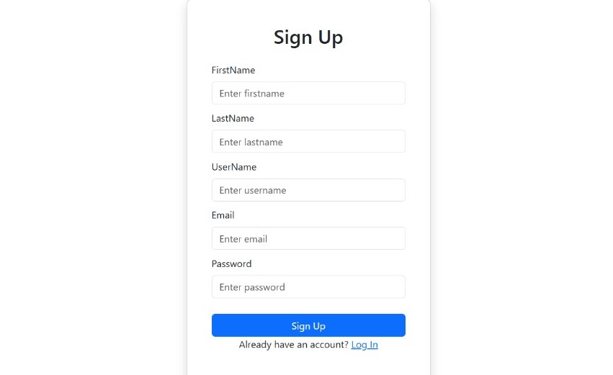

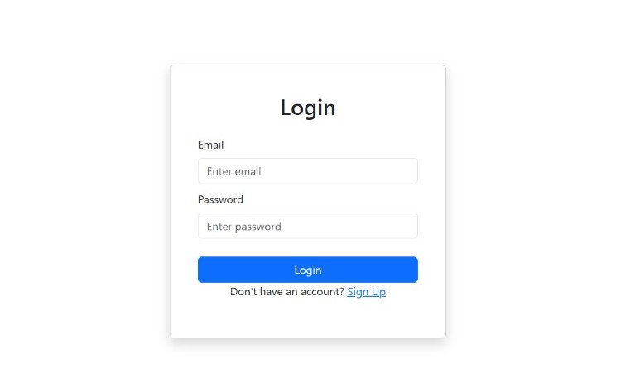

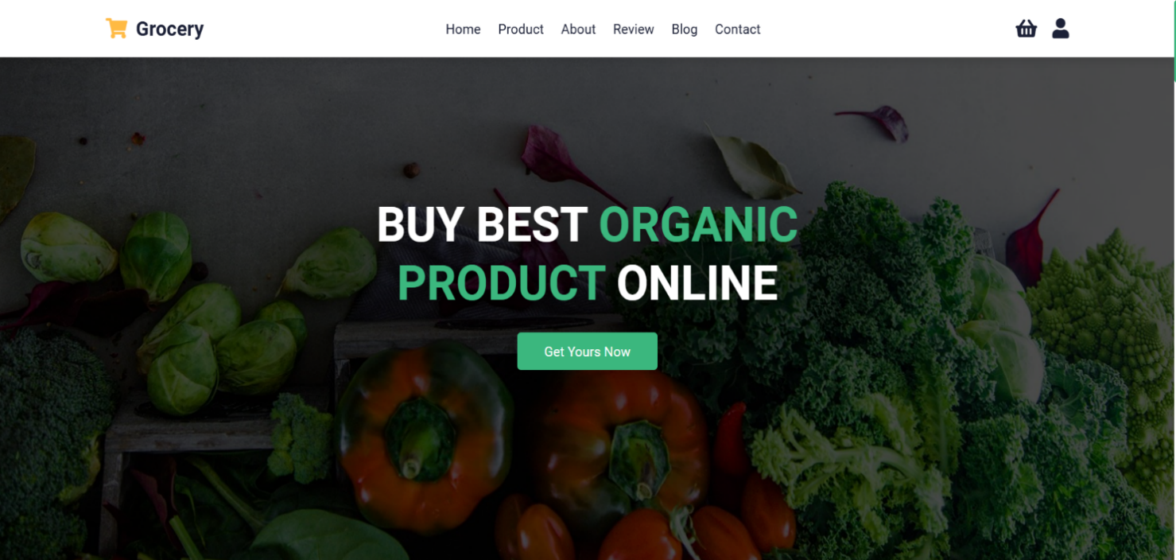

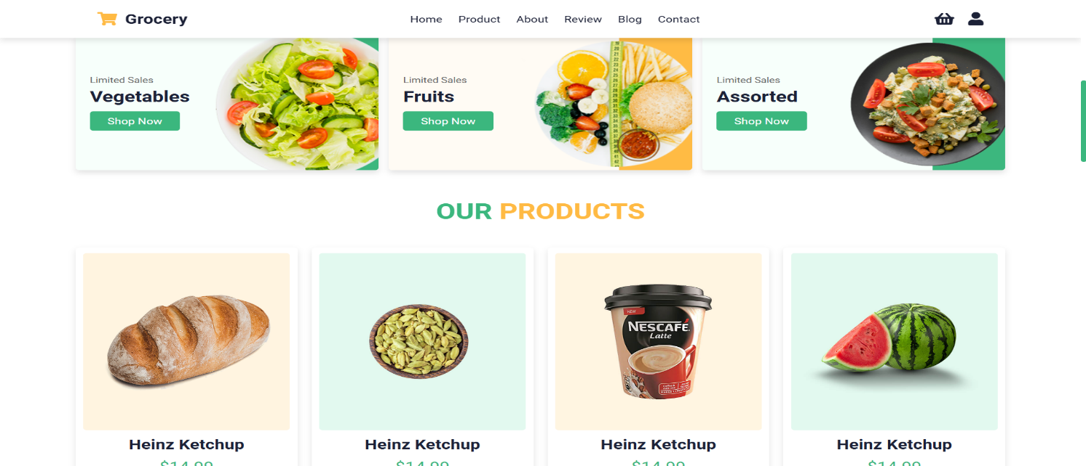

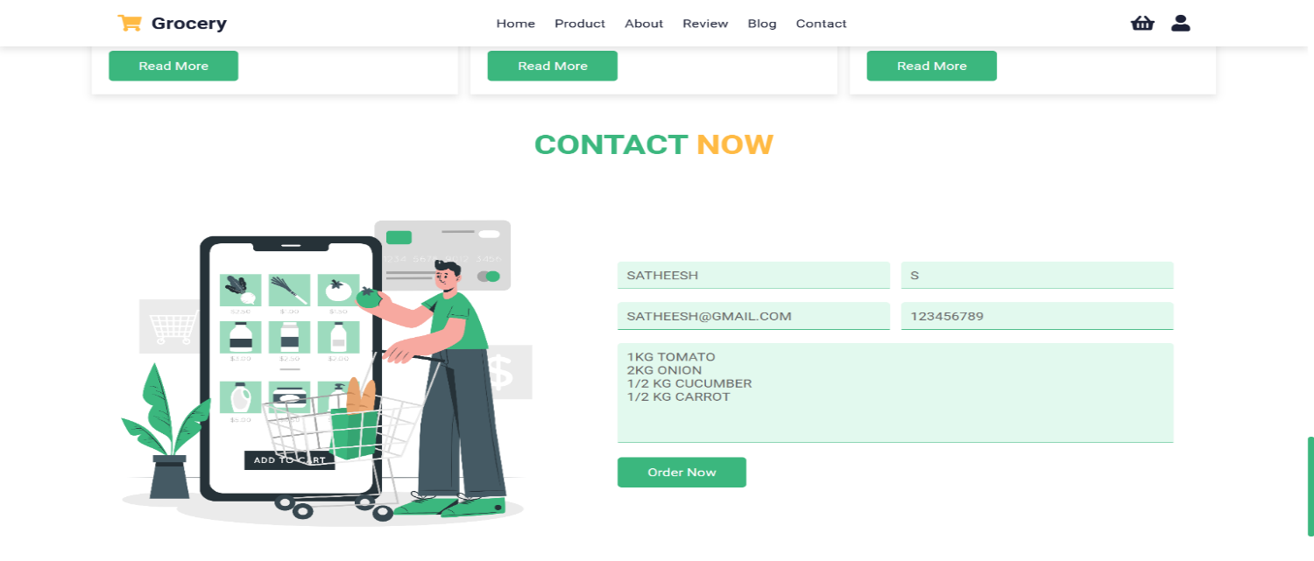

Visual assets such as screenshots of the homepage, product pages, and checkout provide users and developers with an illustrative overview of the application’s interface. For a more interactive experience, a live demo link or video walkthrough can further demonstrate the app’s features.

**12. Known Issues**

The app currently has a few known issues that are being addressed:

- There are minor UI inconsistencies on specific mobile screen sizes.

- Occasional delays in order confirmation can occur during peak server load.

**13. Future Enhancements**

To continuously improve the app, several future enhancements are planned, including:

- Adding multi-language support to expand accessibility for users of different languages.

- Implementing a recommendation engine to offer personalized product suggestions based on user purchase history.

- Enhancing seller analytics with detailed insights into sales trends and inventory forecasts, empowering sellers with data-driven tools.

This detailed report captures the project’s key features, technical setup, and functionality, providing a comprehensive reference for users and developers alike to understand, set up, and contribute to the grocery web app.